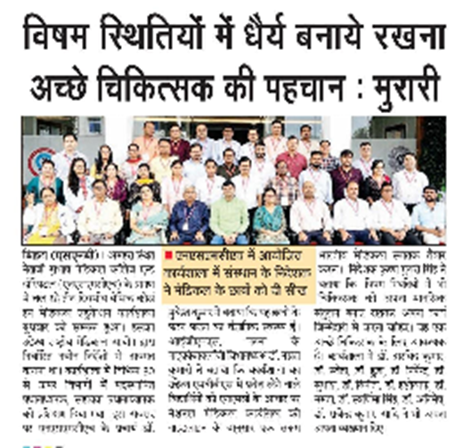**

**Workshop Details**

**Date:** 22nd and 24th July

**Venue:** Netaji Subhas Medical College and Hospital (NSMCH), Bihta, Patna

**Duration:** 3 days

**Participants:** 30 Professors and Assistant Professor from over 30 departments

**Objectives**

* To enhance the quality of medical education
* To prepare competent Indian medical graduates as per National Medical Commission (NMC) guidelines
* To focus on both medical knowledge and moral values

**Key Takeaways**

* Scientific form of teaching and learning for students.
* Trained doctors to increase the quality of medical education.
* Emphasis on moral values along with medical knowledge.

**Speakers**

* Mr. Krishna Murari, Managing Director
* Dr. Ashok Sharan, College Principal
* Dr. Namrata Kumari, Head of Microbiology Department, IGMs Patna .

**Outcome**

Participants gained insights into the new instructions laid down by the National Medical Commission

Enhanced understanding of the importance of moral values in medical education

Equipped with skills to prepare competent Indian medical graduates

**Recommendations**

Conduct regular workshops to update faculty members on the latest NMC guidelines

Incorporate moral values and ethics into the medical curriculum

Encourage continuous professional development for faculty members

**Conclusion**

The BCME workshop was a successful initiative to enhance the quality of medical education. The participants gained valuable insights into the new NMC guidelines and the importance of moral values in medical education. The workshop's outcome will contribute to preparing competent Indian medical graduates.

